# JAVA PRACTICE PROGRAM

# MODULE 1 (SECTION -7.3)

1.

**Step 1: Create the package and class structure**

Since many online Java compilers don't support custom package creation, I'll provide the code without explicitly placing it in a package.

**Vehicle.java**

**CODE:**

public class Vehicle {

public static String MAKE = "Augur";

public static int numVehicles = 0;

private String chassisNo;

private String model;

public Vehicle(String model) {

numVehicles++;

this.chassisNo = "ch" + numVehicles;

this.model = model;

System.out.println("Vehicle manufactured");

}

public String getChassisNo() {

return chassisNo;

}

public void setChassisNo(String chassisNo) {

this.chassisNo = chassisNo;

}

public String getModel() {

return model;

}

public void setModel(String model) {

this.model = model;

}

@Override

public String toString() {

return "The vehicle is manufactured by: " + MAKE + "\n" +

"The model type is: " + model + "\n" +

"The chassis number is: " + chassisNo;

}

}

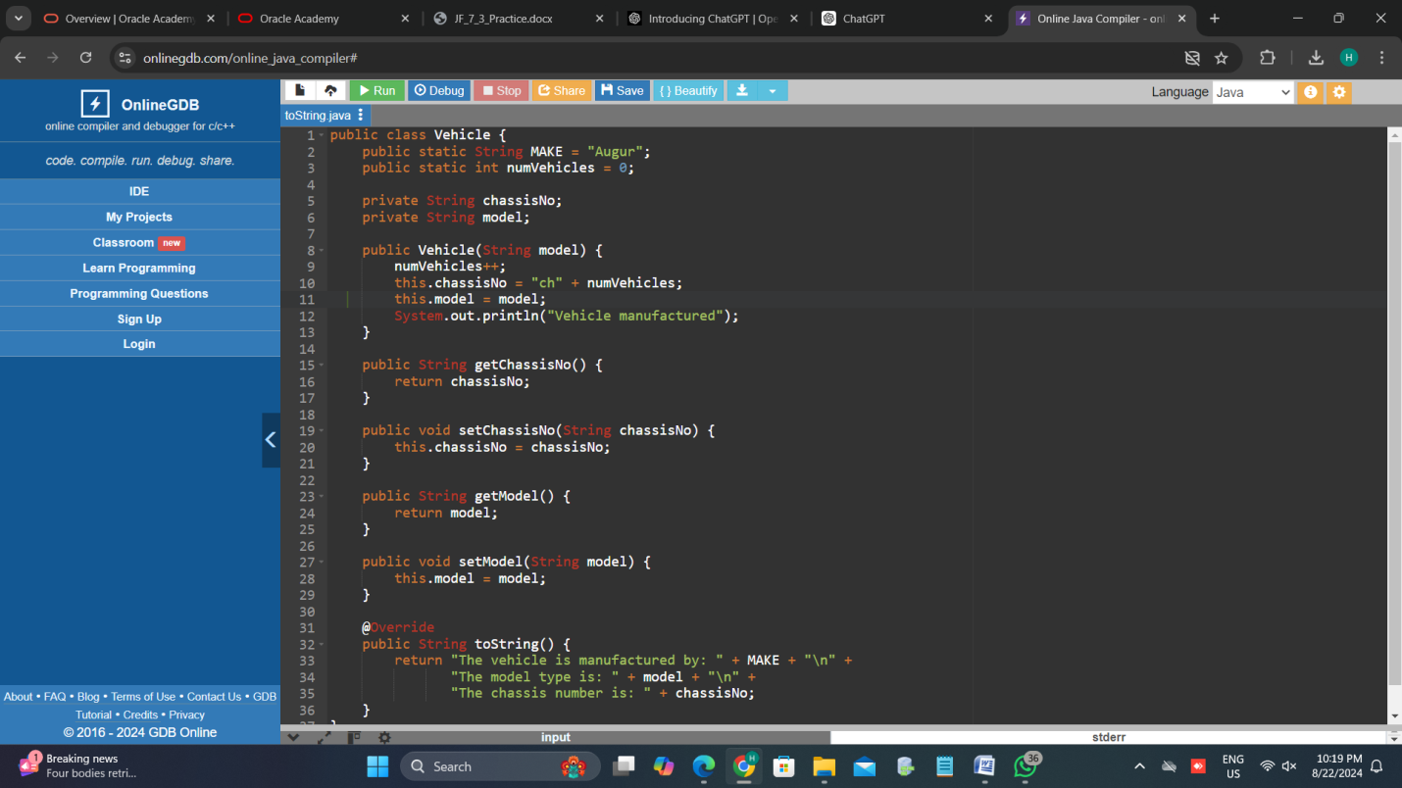

2.

**CODE:**

**Vehicle.javapublic**

class Vehicle {

public static String MAKE = "Augur";

public static int numVehicles = 0;

private String chassisNo;

private String model;

public Vehicle(String model) {

numVehicles++;

this.chassisNo = "ch" + numVehicles;

this.model = model;

System.out.println("Vehicle manufactured");

}

public String getChassisNo() {

return chassisNo;

}

public void setChassisNo(String chassisNo) {

this.chassisNo = chassisNo;

}

public String getModel() {

return model;

}

public void setModel(String model) {

this.model = model;

}

public static void setMake(String make) {

MAKE = make;

}

@Override

public String toString() {

return "The vehicle is manufactured by: " + MAKE + "\n" +

"The model type is: " + model + "\n" +

"The chassis number is: " + chassisNo;

}

}

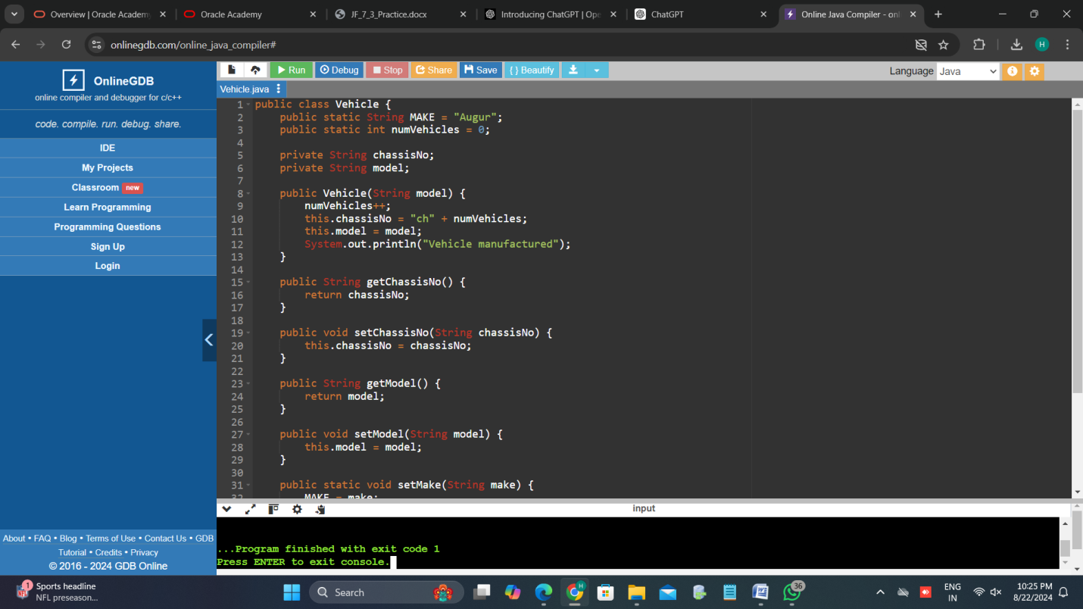

**TestVehicle.java**

**CODE:**

public class TestVehicle {

public static void main(String[] args) {

System.out.println("Manufacturer: " + Vehicle.MAKE);

System.out.println("Number of vehicles manufactured: " + Vehicle.numVehicles);

Vehicle vehicle1 = new Vehicle("Vision");

System.out.println(vehicle1.toString());

Vehicle vehicle2 = new Vehicle("Edict");

System.out.println(vehicle2.toString());

vehicle2.setMake("Seer");

System.out.println(vehicle1.toString());

System.out.println(vehicle2.toString());

System.out.println("Number of vehicles manufactured: " + Vehicle.numVehicles);

}

}

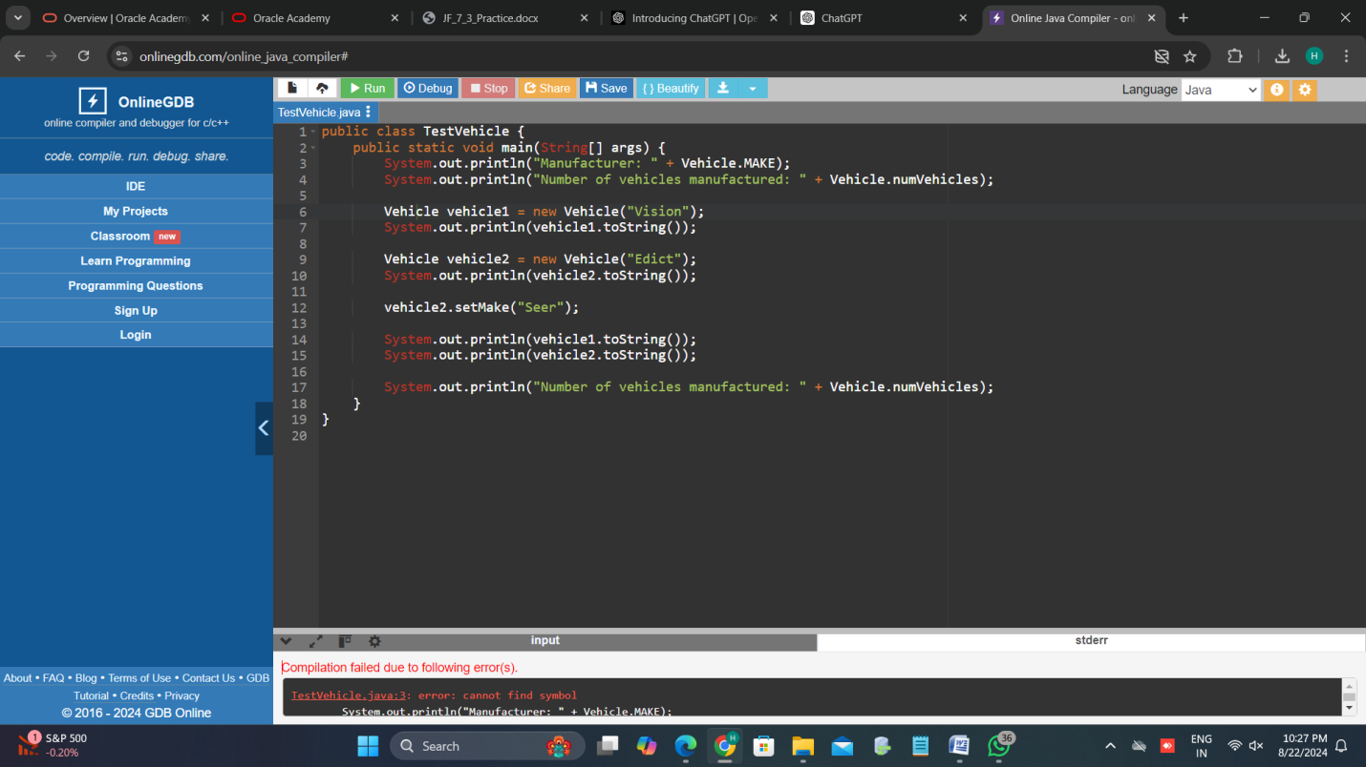

**OUTPUT:**

Manufacturer: Augur

Number of vehicles manufactured: 0

Vehicle manufactured

The vehicle is manufactured by: Augur

The model type is: Vision

The chassis number is: ch1

Vehicle manufactured

The vehicle is manufactured by: Augur

The model type is: Edict

The chassis number is: ch2

The vehicle is manufactured by: Seer

The model type is: Vision

The chassis number is: ch1

The vehicle is manufactured by: Seer

The model type is: Edict

The chassis number is: ch2

Number of vehicles manufactured: 2

3.

**Vehicle.java**

**CODE:**

public class Vehicle {

public static String MAKE = "Augur";

public static int numVehicles = 0;

private String chassisNo;

private String model;

public Vehicle(String model) {

numVehicles++;

this.chassisNo = "ch" + numVehicles;

this.model = model;

System.out.println("Vehicle manufactured");

}

public String getChassisNo() {

return chassisNo;

}

public void setChassisNo(String chassisNo) {

this.chassisNo = chassisNo;

}

public String getModel() {

return model;

}

public void setModel(String model) {

this.model = model;

}

public static void setMake(String make) {

MAKE = make;

}

@Override

public String toString() {

return "The vehicle is manufactured by: " + MAKE + "\n" +

"The model type is: " + model + "\n" +

"The chassis number is: " + chassisNo + "\n" +

"The engine make is: " + Engine.getMake() + "\n" +

"The engine capacity is: " + Engine.getCapacity() + "cc";

}

public static class Engine {

private static final String MAKE = "Predicter";

private static final int CAPACITY = 1600;

public static String getMake() {

return MAKE;

}

public static int getCapacity() {

return CAPACITY;

}

}

}

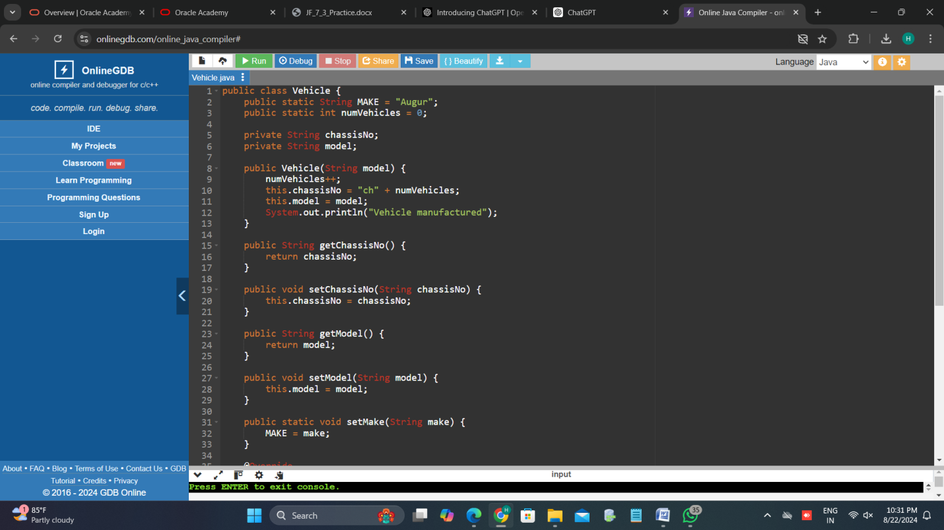

**TestVehicle.java**

CODE:

public class TestVehicle {

public static void main(String[] args) {

System.out.println("Manufacturer: " + Vehicle.MAKE);

System.out.println("Number of vehicles manufactured: " + Vehicle.numVehicles);

Vehicle vehicle1 = new Vehicle("Vision");

System.out.println(vehicle1.toString());

Vehicle vehicle2 = new Vehicle("Edict");

System.out.println(vehicle2.toString());

vehicle2.setMake("Seer");

System.out.println(vehicle1.toString());

System.out.println(vehicle2.toString());

System.out.println("Number of vehicles manufactured: " + Vehicle.numVehicles);

}

}

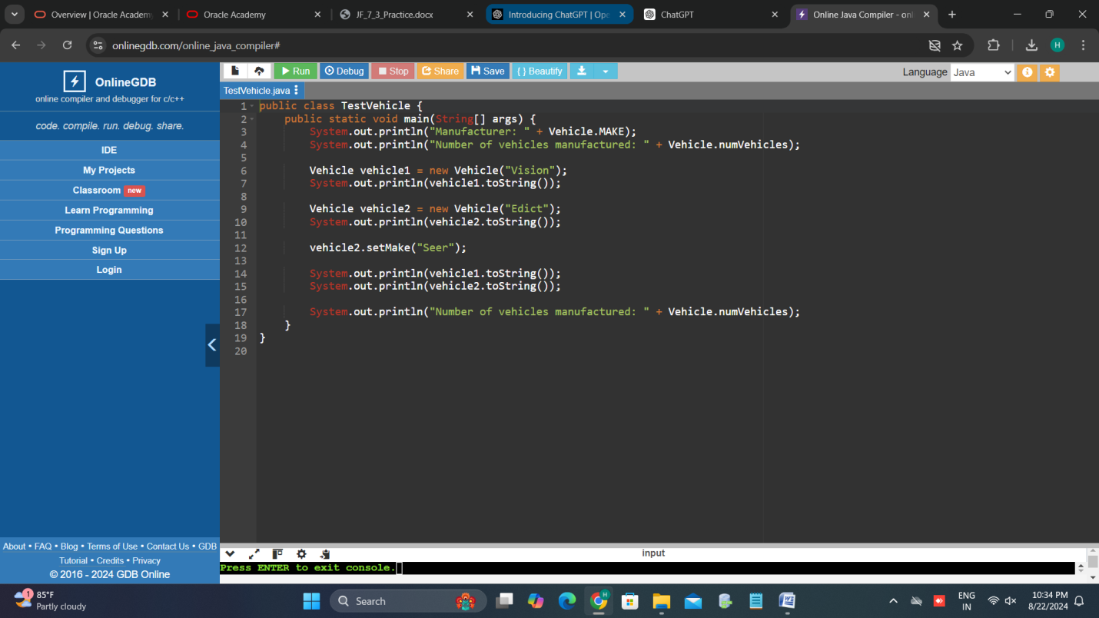

**OUTPUT:**

Manufacturer: Augur

Number of vehicles manufactured: 0

Vehicle manufactured

The vehicle is manufactured by: Augur

The model type is: Vision

The chassis number is: ch1

The engine make is: Predicter

The engine capacity is: 1600cc

Vehicle manufactured

The vehicle is manufactured by: Augur

The model type is: Edict

The chassis number is: ch2

The engine make is: Predicter

The engine capacity is: 1600cc

The vehicle is manufactured by: Seer

The model type is: Vision

The chassis number is: ch1

The engine make is: Predicter

The engine capacity is: 1600cc

The vehicle is manufactured by: Seer

The model type is: Edict

The chassis number is: ch2

The engine make is: Predicter

The engine capacity is: 1600cc

Number of vehicles manufactured: 2

4.

**Vehicle.java**

**CODE:**

public class Vehicle {

public static String MAKE = "Augur";

public static int numVehicles = 0;

private String chassisNo;

private String model;

public Vehicle(String model) {

numVehicles++;

this.chassisNo = "ch" + numVehicles;

this.model = model;

System.out.println("Vehicle manufactured");

}

public String getChassisNo() {

return chassisNo;

}

public String getModel() {

return model;

}

public static void setMake(String make) {

MAKE = make;

}

@Override

public String toString() {

return "The vehicle is manufactured by: " + MAKE + "\n" +

"The model type is: " + model + "\n" +

"The chassis number is: " + chassisNo + "\n" +

"The engine make is: " + Engine.getMake() + "\n" +

"The engine capacity is: " + Engine.getCapacity() + "cc";

}

public static class Engine extends Vehicle {

private static final String MAKE = "Predicter";

private static final int CAPACITY = 1600;

public Engine(String model) {

super(model);

}

public static String getMake() {

return MAKE;

}

public static int getCapacity() {

return CAPACITY;

}

}

}

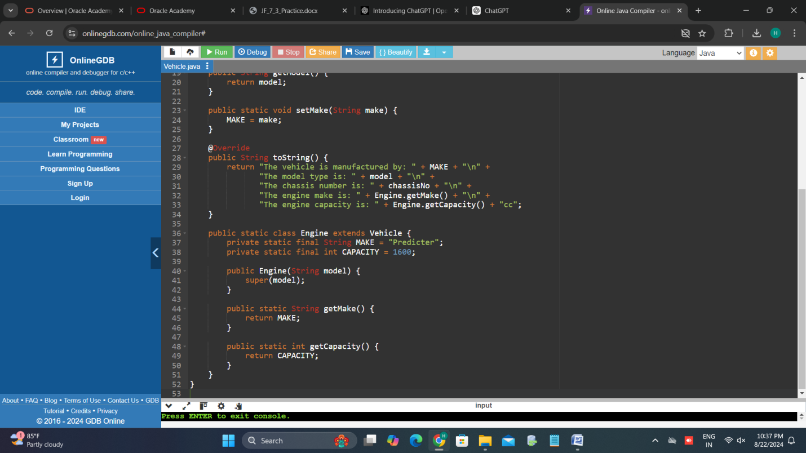

**TestVehicle.java**

CODE:

public class TestVehicle {

public static void main(String[] args) {

System.out.println("Manufacturer: " + Vehicle.MAKE);

System.out.println("Number of vehicles manufactured: " + Vehicle.numVehicles);

Vehicle vehicle1 = new Vehicle("Vision");

System.out.println(vehicle1.toString());

Vehicle vehicle2 = new Vehicle("Edict");

System.out.println(vehicle2.toString());

// Creating an Engine object (which is also a Vehicle) with model "Fortune"

Vehicle.Engine vehicle3 = new Vehicle.Engine("Fortune");

System.out.println("Vehicle number " + vehicle3.getChassisNo() +

" is a " + vehicle3.getModel() +

" model and has an engine capacity of " +

Vehicle.Engine.getCapacity() + "cc");

vehicle2.setMake("Seer");

System.out.println(vehicle1.toString());

System.out.println(vehicle2.toString());

System.out.println("Number of vehicles manufactured: " + Vehicle.numVehicles);

}

}

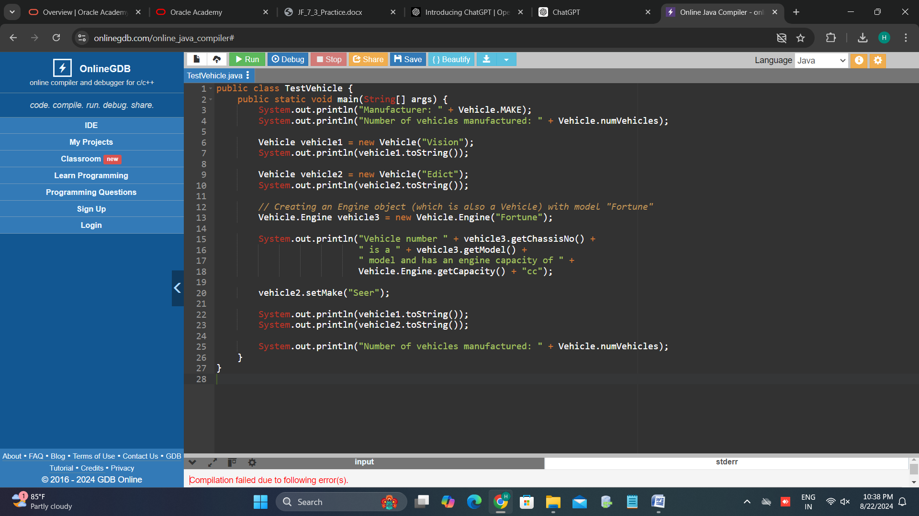

OUTPUT:

Manufacturer: Augur

Number of vehicles manufactured: 0

Vehicle manufactured

The vehicle is manufactured by: Augur

The model type is: Vision

The chassis number is: ch1

The engine make is: Predicter

The engine capacity is: 1600cc

Vehicle manufactured

The vehicle is manufactured by: Augur

The model type is: Edict

The chassis number is: ch2

The engine make is: Predicter

The engine capacity is: 1600cc

Vehicle number ch3 is a Fortune model and has an engine capacity of 1600cc

The vehicle is manufactured by: Seer

The model type is: Vision

The chassis number is: ch1

The engine make is: Predicter

The engine capacity is: 1600cc

The vehicle is manufactured by: Seer

The model type is: Edict

The chassis number is: ch2

The engine make is: Predicter

The engine capacity is: 1600cc

Number of vehicles manufactured: 3